Current Trend Analysis

For finding the Most Trending Product on the website we will do the web scrapping of the NEW ARRIVAL section as most of the audience will go to that particular section of the website. There we can extract the data for most reviews and the comments that will give us an idea about the product which is most engaged.

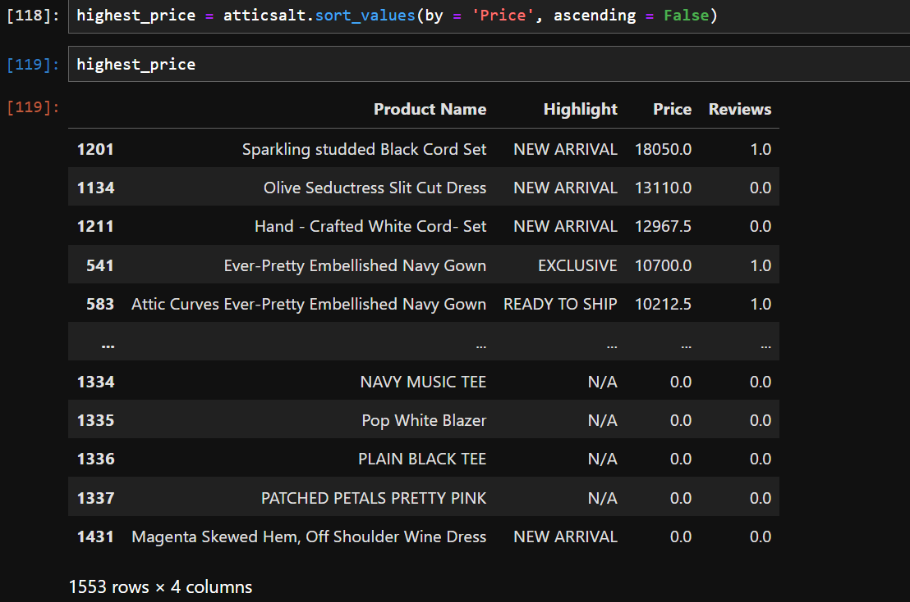

It is found that the products with the highest price has least number of reviews and also they are highlighted with NEW ARRIVAL.

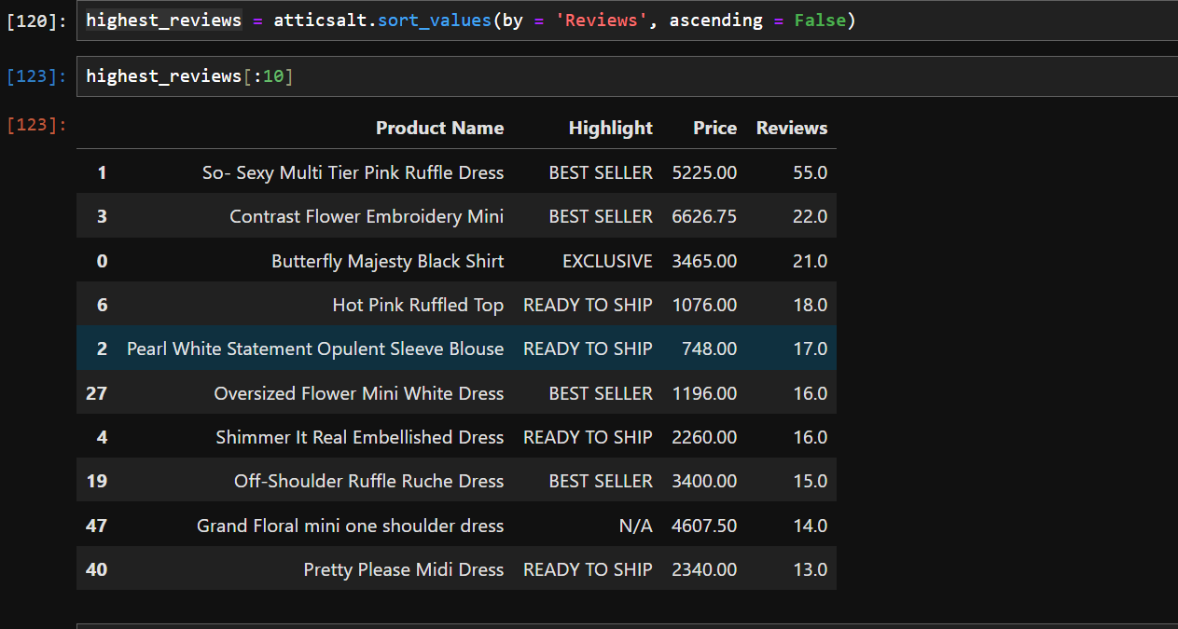

Top 10 products with highest Reviews are above and they are on a high price category and only one product is below 1000 rupees.

Based on analyzing reviews only three products have ratings over 20.

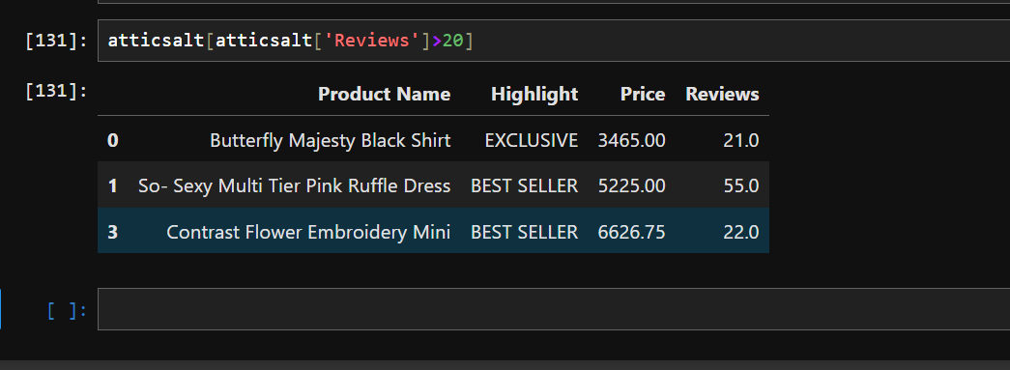

Only 20 products have ratings over 9.

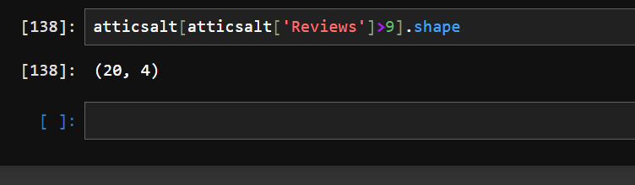

As I web scrapped the data from the section of the website that has new arrivals which can be *Proved* by the following data, as the highest Highlight of products is NEW ARRIVAL.

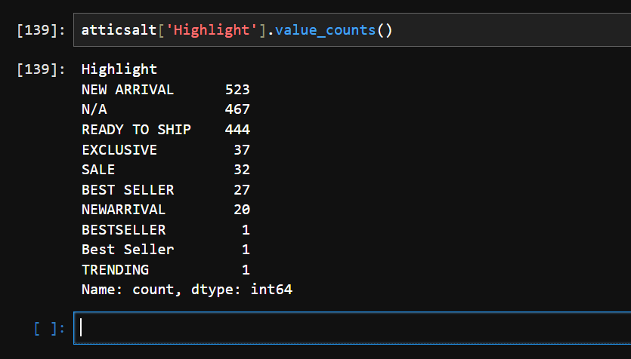

# For Labellife data

Only two products have price over 5000.

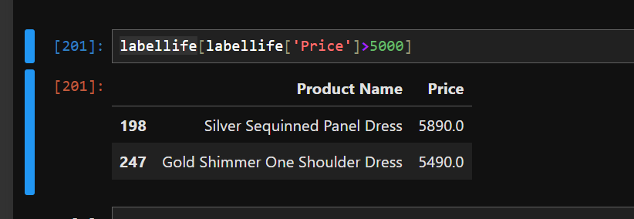

526 products have price over 1000.

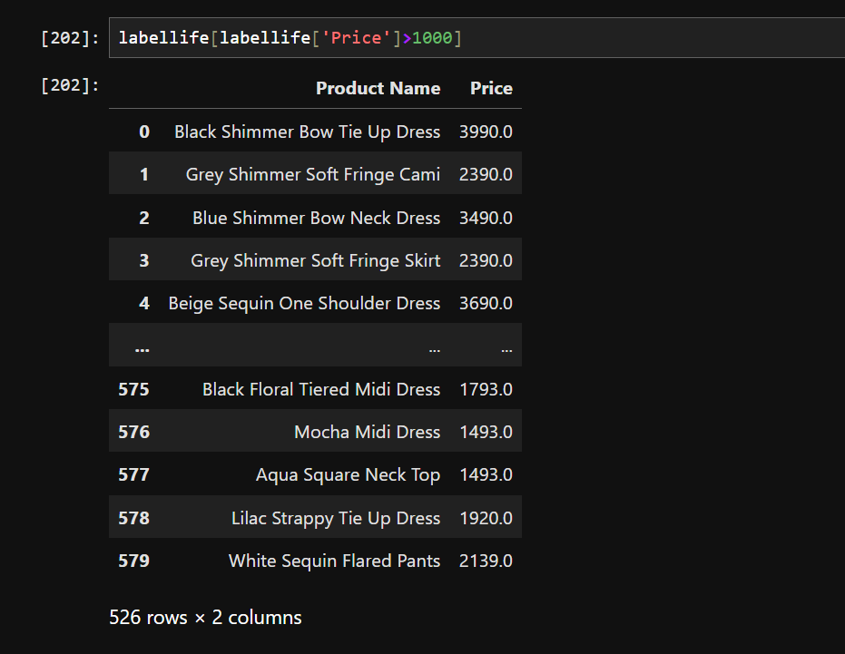

From the below screen shot we can find that 54 products has name but the price is not mentioned while scrapping the data as class or HTML tag can not be tracked.

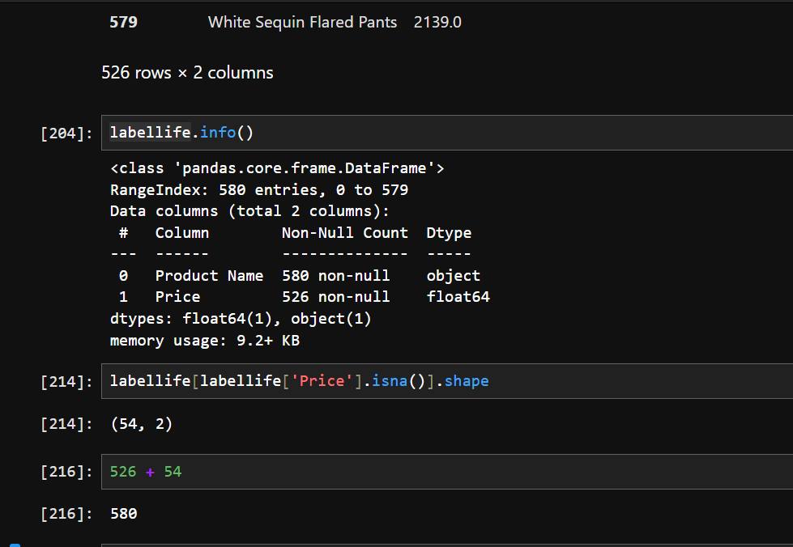

All the products of the that have price above 1000.

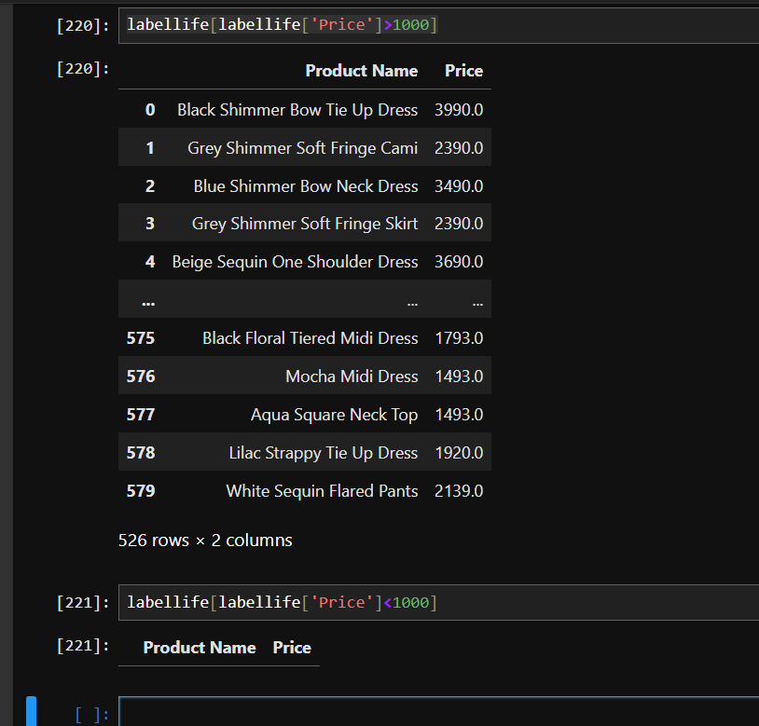

Products offered in Black on the Fablestreet are the most as it has the highest count.

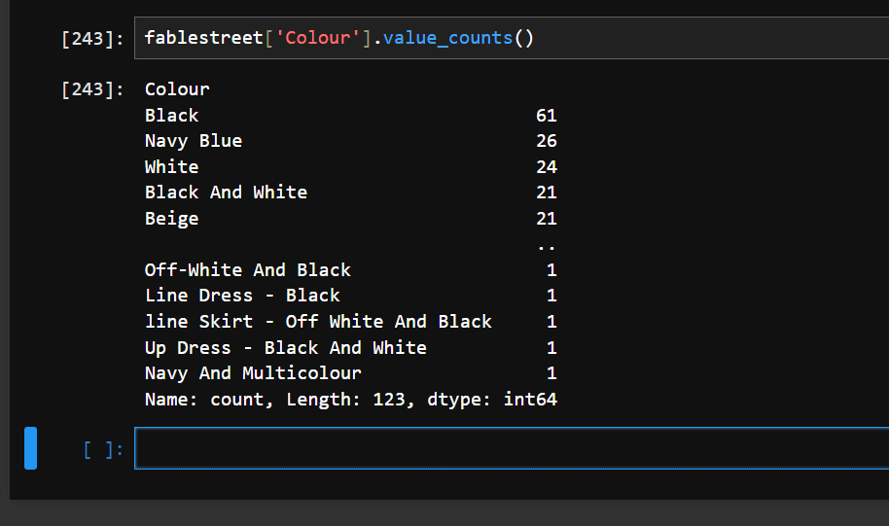

Highest product with Black color is



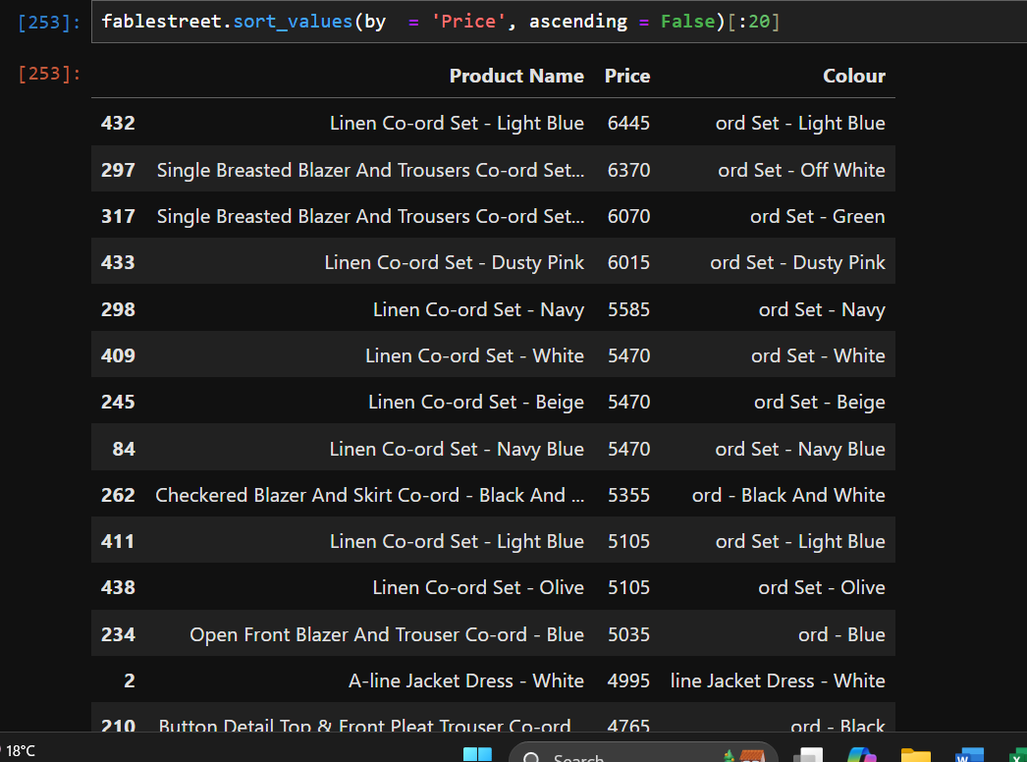

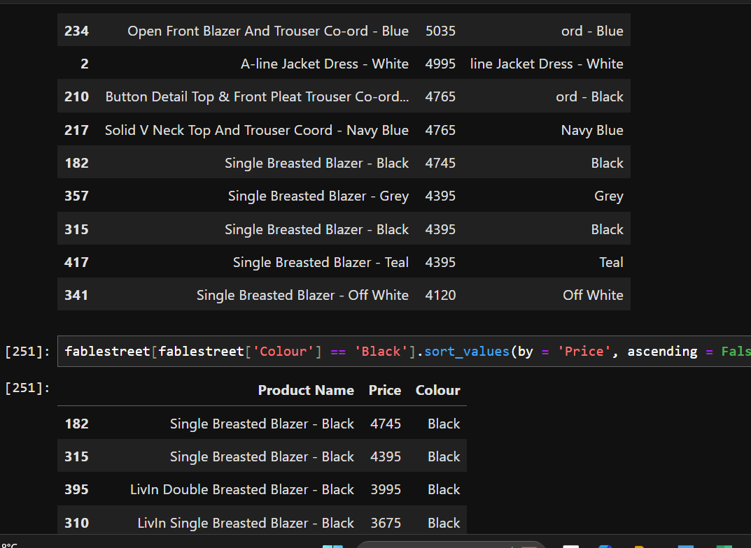

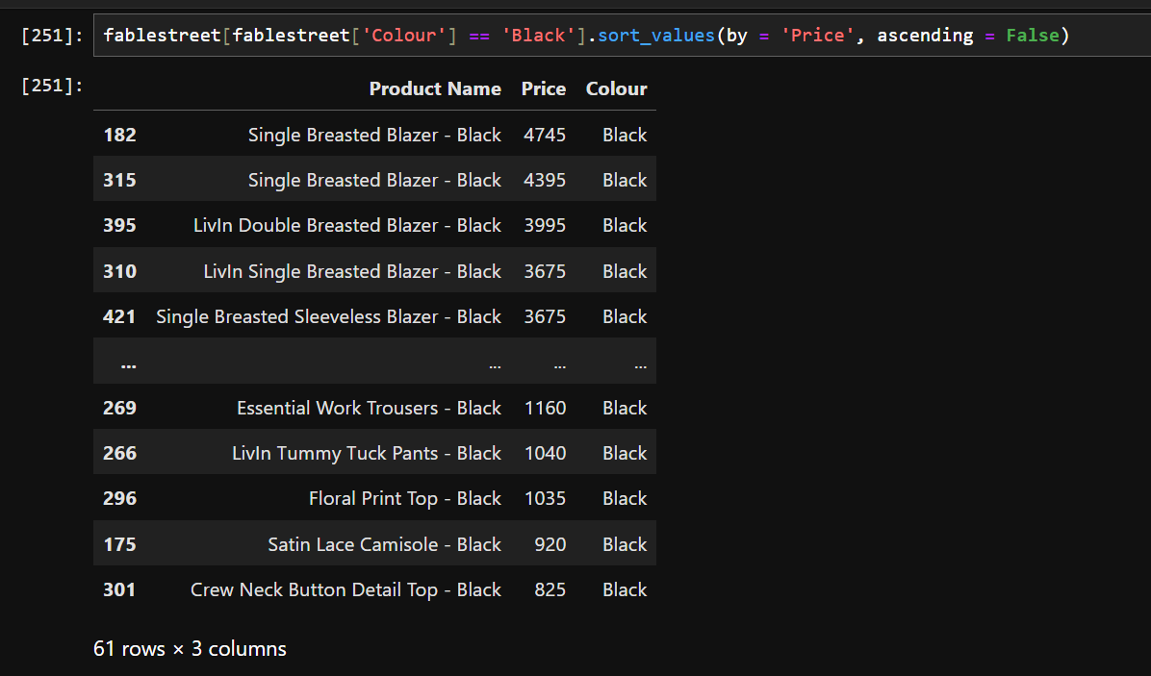

Top 15 colors.

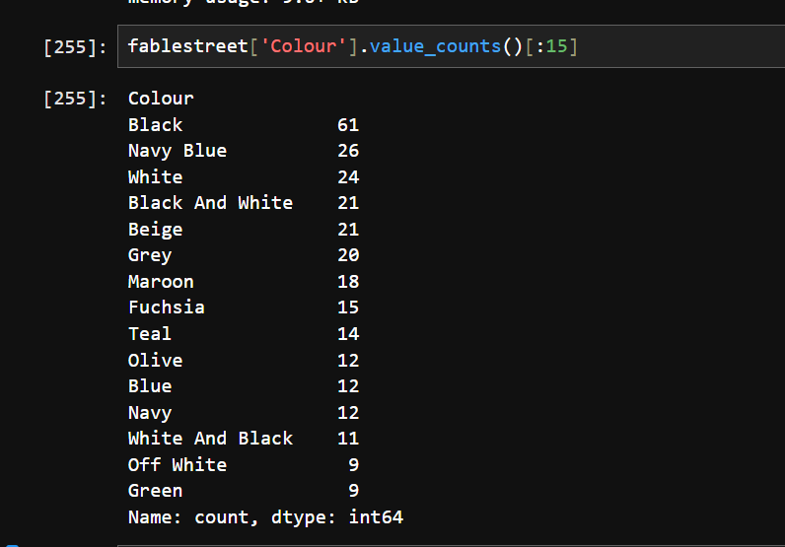

In the webpage of AJIO over 21 products are above Rupees 1000.

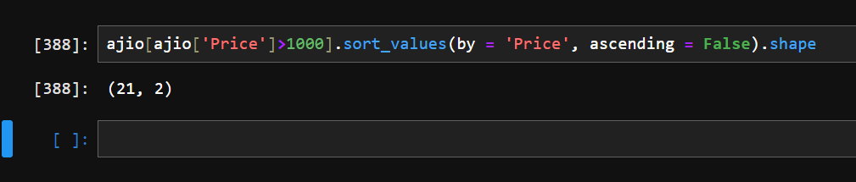

Historical Trend Analysis

For finding the Historical Trend Analysis I went to the all-purchase section of the website where all the listed products of the website is present and from there we will extract the data which will cover most reviews and comments that will helps us in finding the most engaged product over the years.

Sentiment Analysis

Sentiment Analysis uses NLP technique that helps in understanding the emotions of the person which he/she buys. We use some given list of words according to which we analysis the comment section of each product and make a judgement accordingly.

Market Research

# Target Audience

Target Audience of the current trendiest products are the PROFESSIONAL WOMEN who are given choices across all the ranges from western wear, ethnic wear, party wear casual wear and many more.

# Pricing Strategy

Pricing of the products is aggressive as it caters the demand for all the women who are college going or are working in the levels of the income.

# Competitive Landscape

A highly competitive market is present in the Asia and Indian Sub-continent as disposable income of the masses is increasing. In one of the reports published in [Grand View Research](https://www.grandviewresearch.com/industry-analysis/women-wear-market) Women Wear Market is over a Trillion Dollar world-wide and around 40% of which comes from the Asian Market.

Also, in recent time in India big corporates have also come in fast fashion to cater the demand for masses.

Some of the companies are:

1. Reliance TREND, AZORTE, AJIO
2. Tata Zudio, WESTSIDE

Also, these big companies are also targeting the audience in all the price range which **Attic Salt** is doing.

Database Creation

For Database Creation I am attaching a Jupyter Notebook file.

As my system is not of the high configuration, I have made limited data base as some section of the give website posses more than 1,00,000 products which was making web scrapping a bit difficult.

However, I have provided the best data base that my system can deliver.